Wilburton Allotments and Sandpits
The Government launched their ‘25 Year Environment Plan’ in 2018, one of its primary focuses is connecting people to their environment and how this can improve health and well-being. Studies in the Netherlands and Canada show that a 10% increase in exposure to green space translated into an improvement in health equivalent to being five years younger. (Journal of Public Health, October 2015)

Allotments can be found in cities, towns and villages across the world, they are green spaces offering vital growing space for people wishing to cultivate their own fruits, flowers and vegetables. Maps displayed in St Peter’s Hall show Parish Allotments in Wilburton from 1902 on the Twentypence Road site. In recent years the site has been somewhat neglected causing the grass to grow to shoulder height and huge tangles of brambles.
When Steve Morgan became a Parish Council in May 2019 he visited the site and saw a way he could make improvements. All Councillors supported Cllr Morgan in the development of the Allotment and Sandpit sites to be more accessible, safer areas for members of the Parish to enjoy. He has put a vast amount of time, energy and enthusiasm into the project, clearing the site, engaging with contractors and working on a woodland trust application to secure trees and hedging to further enhance the site.
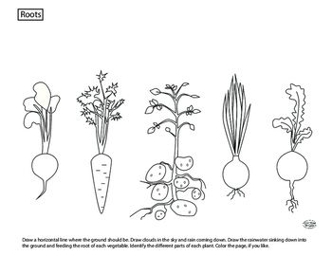
Councillors have worked on defining boundaries at both the Allotments and the Sandpit sites which now means that these two, Parish owned, spaces can be secured, maintained and used by villagers, the local school and groups (such as guides and scouts) for outside learning opportunities.
Grow your own …..
In the summer of 2019 Wilburton Parish Council were approached by the New Life on the Old West to be part of their wider vision ‘to deliver a range of enhancements to wildlife habitats across the landscape around the Old West river, as well as offering a range of nature - based learning, engagement, and volunteering opportunities for local people and communities.’ The Allotment and Sandpit sites are set to be part of this project with the inclusion of a wildlife pond on the Allotments site and some planting of fruit trees, acknowledging the Orchard rich history of our village.
The new look Twentypence Allotments will soon be ready for hand over, each plot will be ready for cultivation with access to water with onsite parking. There are still a few allotment plots available
If you live within the Parish and you would like to ‘grow your own’ then please get in contact.
Email: assistantclerk@wilburtonparishcouncil.org

